2006-11-21 [1037] Ta2O5 Wafer 2 Map 11212006

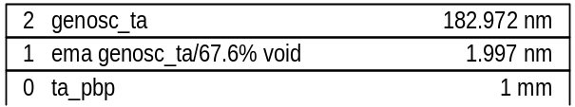

MSE=19.11
thick.2 182.972±0.167
thick.1 1.997±0.103
ema2.1 67.61±2
br1.2 0.63386±0.00976
en1.2 4.909±0.0103
amp1.2 2.8262±0.0525
polemag.2 110.81±0.68
e1offset.2 1.6745±0.00938

